

THE IMPORTANCE OF SOIL FOR PLANT LIFE

Erasmus + team Croatia: Tamara Banović, Marin Juraga , Ivica Štrbac, Ivana Zemunik
INTRODUCTORY TASK
Complete the table by answering the questions:
Why soil is important:
To the farmer

To the builder

Earthworms

Birds

Holm oak

PROPERTIES AND IMPORTANCE OF SOIL
Use the tables to determine the consistency, structure, and texture of the sample!
Task 1. Soil strength
Use the table to determine the consistency of the soil!
consistency ( Late Latin : consistentia ) - solidity, density, conciseness, solidity; constancy, durability, endurance; the structure of a body
CONSISTENCY _______________________
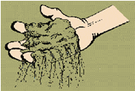 | Loose :​  Individual lumps of soil are difficult to find, the structure falls apart when handling the sample.
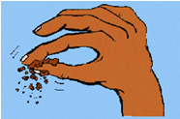 | Brittle, crumbly ( friable ):  The consistency is lost with little pressure, the lump ( ped ) breaks with little force.
 | Firm ( firm ): the lump ( ped ) only breaks under strong pressure.
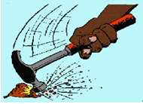 | Very tight ( extremly) company ):  A lump ( ped ) cannot be crushed with your hands, a hammer is needed.

Task 2. Soil structure
With the help of the table, determine the structure of the soil!
structure (lat. structura : structure, construction) - the way a whole is composed of its elements (parts, members, details)
STRUCTURE:_________________________
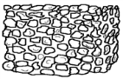 | 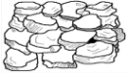 | 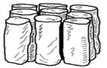 | 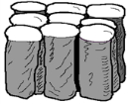 | 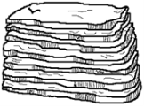 | 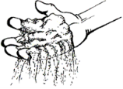 | 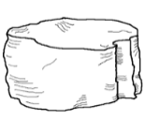
Granular (granular ) | Clumpy or rocky (blocky ) | Prismatic​​​ | Columnar​​​ | Shallow  (salaries ) | Single grained​ | Massive​​

Task 3. Soil texture
3.1. According to the size of the mineral particles in the soil, we divide them into sand (the largest and heaviest particles), clay (the smallest and lightest particles), and dust. The following experiment will reveal how much sand, clay, and dust is in your sample, and use the three-component diagram to determine what type of soil your samples belong to!
PROCEDURE: Pour 30 mL of soil sample into a 100 mL measuring cylinder and shake gently to settle. Fill the measuring cylinder to 90 mL with distilled water, close the measuring cylinder with a stopper, lid or by hand and shake up and down for a minute. After a minute, let the measuring cylinder stand for 40 seconds and read the volume of the settled particles. Let the measuring cylinder stand for another 20 minutes and read the volume again. While waiting for the second settling, do the second part of the task – 3.2.
Fill in the table for sample 1 .
I observe: | start of the experiment | after 40 seconds | after 20 minutes
volume of settled soil | 30 mL
type of precipitated particles | sand, dust and clay
scale drawing

Fill in the table for sample 2.
I observe: | start of the experiment | after 40 seconds | after 20 minutes
volume of settled soil | 30 mL
type of precipitated particles | sand, dust and clay
scale drawing
Based on the data for the volume of settled soil and the type of settled particles, calculate the volume fraction of sand, silt, and clay in your soil samples and use a three-component diagram to determine the texture of your samples.
 | Volume fraction % | Volume fraction %
Type of soil particles | Sample 1 - ___________________ | Sample 2 - ___________________
Sand
Prague
Clay

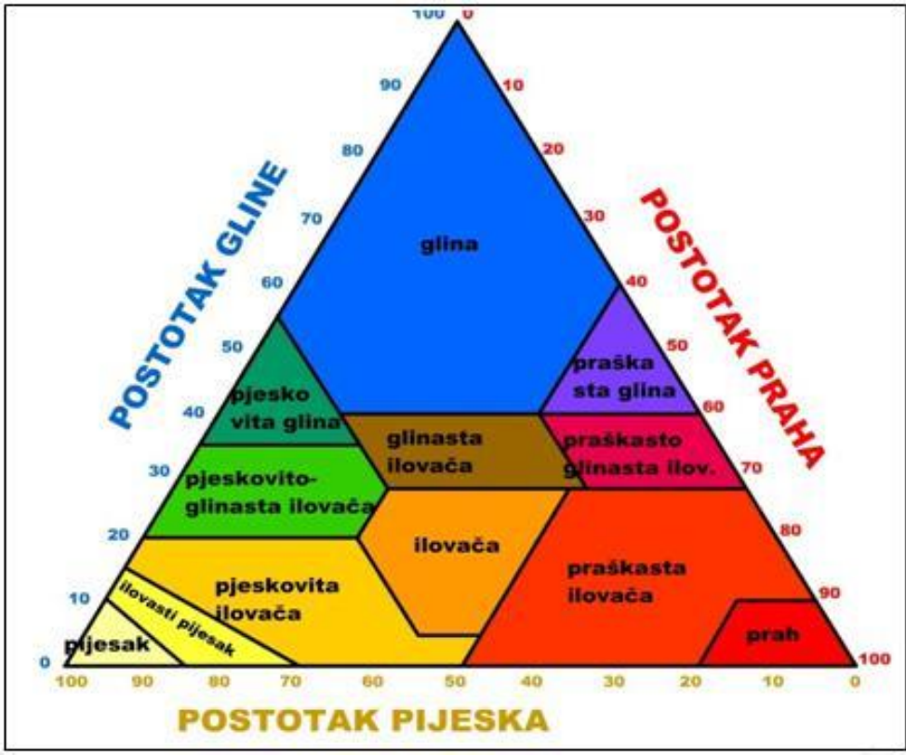 Three-component diagram for determining soil texture ( Soil Survey Staff , 1951, adapted by Alduk , 2017)
Task:
In a 60 mL soil sample, it was determined by a measuring cylinder to consist of 39 mL of sand and 12 mL of dust, with the remainder being clay.
- Calculate the percentage of sand, silt, and clay in the sample.

- Using the three-component diagram, determine the type of soil.

3.2. Depending on the amount of individual particles in the soil, soil can be roughly divided into clay, sand and loam. Where clay contains the most clay particles, sand contains the most sand particles and loam contains equal amounts of sand and silt and a little clay.
- Take some soil (the size of a small egg) in your hand and moisten it with water using a squirt bottle. Once the water is absorbed, knead the sample and work it out between your fingers. When the soil is moist, try to make a ball.
- If you managed to form a ball, go to step 2.
- If you cannot form a ball, your sample is sand . The texture test is complete.
- Take a ball of soil between your thumb and forefinger, gently kneading it to make a ribbon.
- If you made a ribbon that is longer than 2.5 cm, go to step 3.
- If the band breaks up before it reaches 2.5 cm, your sample is loamy sand sand ) and that completes the texture test.
- If your soil is:
- / leaves stains on hands/shines when rubbed/forms a long string (5+ cm) without breaking apart, you have clay .
- somewhat sticky/quite difficult to knead/forms a medium-long ribbon (between 2.5 and 5 cm) it is clay loam ( loam ).
- smooth/easy to knead/usually slightly sticky/forms a short ribbon (less than 2.5 cm), your soil is loam .
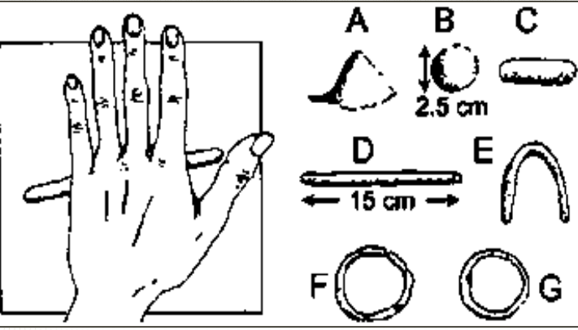
- Figure 6. Feel method (FAO 2000).
- A - sand - no shapes can be formed by rolling
- B – sandy loam – a ball can form that easily breaks apart
- C – powdery loam – the soil can be rolled into short and thick rolls
- D – clay – a roll about 15 cm long can be formed before cracking
- E – clay loam – rolling forms rollers that can be modeled into a U shape without cracking
- F – sandy clay – the soil can be easily bent into a circle with a few cracks
- G – clay – soil can be shaped like plasticine and made into a circle without any cracks

Sample 1. according to texture is ________________________________
Sample 2. according to texture is _______________________________

Task 4. pH – soil value
Soils also differ in pH value, they can be acidic, neutral, and alkaline . Your task is to determine what your soil sample is like, so using the provided equipment and chemicals, devise a way to test whether your samples are acidic, neutral, or alkaline.
Materials and equipment: watch glasses, syringe bottle, soil samples, spoons, baking soda, vinegar, distilled water
Workflow | Notes

Conclusion:
Sample 1 is a) acidic b) neutral c) alkaline (circle the letter in front of the correct answer)
Sample 2 is a) acidic b) neutral c) alkaline (circle the letter in front of the correct answer)
- On the basis of which observation did you conclude what type of soil it is in terms of acidity?
___________________________________________________________________________
___________________________________________________________________________
___________________________________________________________________________
- When is soil calcification performed? Name one traditional way of implementation.
___________________________________________________________________________
___________________________________________________________________________

Check the accuracy of your conclusions by testing the pH value of your samples with universal litmus paper.
Required
- dry, sifted soil
- distilled water
- 100 ml measuring cup
- 4 glasses of 100 ml
- scale (accuracy 0.1 g)
- Glass rod or other mixing tool
- pH meter or indicator papers
Preparation
1. In a glass, mix 40 g of dry and sieved soil and 40 ml of distilled water (or other values in a 1:1 ratio). Stir until the mixture is well mixed.
2. Stir the mixture for 30 seconds every 3 minutes for five rounds of stirring and waiting. Allow the mixture to settle and form a supernatant (a clearer layer of liquid above the sediment), this should take about 5 minutes.
3. Using indicator strips or a pH meter, determine the pH value of the supernatant . Place the bottom of the pH meter in the supernatant and measure the pH value and record the value.
4. Repeat the process to get more values for each layer.
Measurement | 1. | 2. | 3. | Mean
pH

Task 5. Soil permeability for water - infiltration
Permeability is the ability of soil to absorb a certain amount of water and allow it to flow through the layers. It allows the soil to retain water that can then be used by living organisms living in the soil. The permeability of the soil to water depends on the texture of the soil, or the size of the soil particles.
Examine your samples visually and by touch and try to predict which soil is more permeable to water, or which has a greater water retention capacity. Explain your answer.
___________________________________________________________________________
___________________________________________________________________________
___________________________________________________________________________
Ask a research question, formulate a hypothesis, and devise a practical way to test your hypothesis. You can use equipment and materials available at your workplace (plastic bottle, measuring cup, glass, water) to design an experiment.

Research question:
_______________________________________________________________________________

_______________________________________________________________________________

Hypothesis (assumption):
_________________________________________________________________________________

_________________________________________________________________________________

Research plan:
_____________________________________________________________________________

_____________________________________________________________________________

Notes during the experiment:
_________________________________________________________________________________

_________________________________________________________________________________

Analysis of results (compare the results of the experiment with your predictions and analysis
soil samples)
_____________________________________________________________________________

_____________________________________________________________________________

Did you confirm or refute your hypothesis?
Conclusion:
_______________________________________________________________________
______________________________________________________________________

the results in the table:
Soil volume
Water volume
Water pouring time
Sample | 1 | 2 | 3
Soil type (brief description)
Assumption:
(mark the most permeable soil with the number 1, and the least permeable with the number 3).
Volume or column of filtered water after 2 minutes
Volume or column of filtered water after 5 minutes
Volume or column of filtered water after 10 minutes
Volume or column of filtered water after 15 minutes
Volume or column of filtered water after 20 minutes
Volume or column of filtered water after 30 minutes
Volume or column of filtered water after 45 minutes
Task 6. Electrical conductivity
Accessories and chemicals: soil sample, plastic bottle, beaker, plastic beaker, laboratory beaker, conductivity meter ,
The soil sample in front of you, based on its texture, belongs to the type of soil we call ______________________
And a research question | Does the electrical conductivity of water change as it passes through soil?
H ypotheses
Research plan
Notes during the experiment

Analysis of results

Conclusion

Let's repeat what we learned! https://gemini.google.com/share/7cd6c90fee9b

