

BOTANY FOR BEGINNERS - DICHOTOMOUS KEY

Erasmus + team Croatia: Tamara Banović, Marin Juraga , Ivica Štrbac, Ivana Zemunik

Name and surname:
Class: Date: ____________________________

Task: On basis morphological characteristic list and twigs on picture, benefits attached expanded dichotomous key to determine which plant species it is.
What is a path? A path is a series of steps (choices between options) that you follow through a dichotomous key until you arrive at the final name of the plant. Each step begins with a number, and you choose the description (a or b) that best describes your plant. Example: If your plant has broad leaves, you start with 1b, then go to 4, etc. Your task is to write down that sequence (e.g. 1b → 4b → 6a).
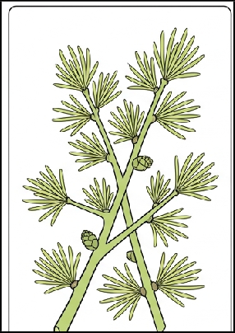

ADVANCED DICHOTOMICAL KEY:

- a) Leaves are in the shape of needles or scales GO ON 2
  - The leaves are broad (the leaflet is expanded) GO ON 4

- a) Needles grow singly and spirally on long shoots COMMON FIR TREE
  - The needles grow in tufts (bundles) on short shoots GO ON 3

- a) The needles are soft, light green; the cones are small (2-4 cm) and upright EUROPEAN LARCH
  - The needles are hard, evergreen; the cones are large (7-12 cm) ATLAS CHEDDAR

- a) The leaf is composed (several smaller leaves) GO ON 5
  - The leaf is simple (one blade) GO ON 6

- a) The leaves are arranged palmately (like fingers) HORSE CHESTNUT
  - The leaves are arranged pinnately (along the petiole) ACACIA

- a) The leaf edge is serrated or deeply incised MOUNTAIN MAPLE
  - The leaf edge is smooth and entire (heart- shaped) COMMON LILAC

Solution (path and name): ______________________________________________________

Name and surname:
Class: Date: ____________________________

Task: On basis morphological characteristic list and twigs on picture, benefits attached expanded dichotomous key to determine which plant species it is.

What is path? Path is a series steps (chooses) among those offered option) which you follow through
dichotomous key all while not you come to final names plants. Each step begins by number, and you you choose the description (a or b) that best suits your plant. Example: If your plant has broad leaves, you start with 1b, then go to 4, etc. Your task is to write down that sequence (e.g. 1b → 4b → 6a).
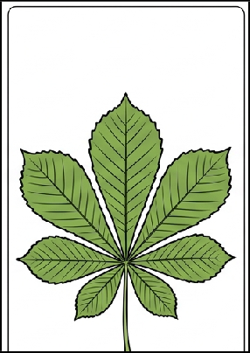

ADVANCED DICHOTOMICAL KEY:

- a) Leaves are in the shape of needles or scales GO ON 2
  - The leaves are broad (the leaflet is expanded) GO ON 4

- a) Needles grow singly and spirally on long shoots COMMON FIR TREE
  - The needles grow in tufts (bundles) on short shoots GO ON 3

- a) The needles are soft, light green; the cones are small (2-4 cm) and upright EUROPEAN LARCH
  - The needles are hard, evergreen; the cones are large (7-12 cm) ATLAS CHEDDAR

- a) The sheet is composed (several smaller sheets) GO ON 5
  - The leaf is simple (one blade) GO ON 6

- a) The leaves are arranged palmately (like fingers) HORSE CHESTNUT
  - The leaves are arranged pinnately (along the petiole) ACACIA

- a) The leaf edge is serrated or deeply incised MOUNTAIN MAPLE
  - The leaf edge is smooth and entire (heart- shaped) COMMON LILAC

Solution (path and name): _________________________________________________________

Name and surname:
Class: Date: ____________________________

Task: On basis morphological characteristic list and twigs on picture, benefits attached expanded dichotomous key to determine which plant species it is.

What is path? Path is a series steps (chooses) among those offered option) which you follow through
dichotomous key all while not you come to final names plants. Each step begins by number, and you you choose the description (a or b) that best suits your plant. Example: If your plant has broad leaves, you start with 1b, then go to 4, etc. Your task is to write down that sequence (e.g. 1b → 4b → 6a).
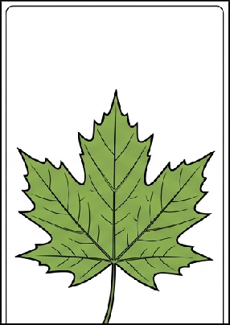

ADVANCED DICHOTOMICAL KEY:

- a) Leaves are in the shape of needles or scales GO ON 2
  - The leaves are broad (the leaflet is expanded) GO ON 4

- a) Needles grow singly and spirally on long shoots COMMON FIR TREE
  - The needles grow in tufts (bundles) on short shoots GO ON 3

- a) The needles are soft, light green; the cones are small (2-4 cm) and upright EUROPEAN LARCH
  - The needles are hard, evergreen; the cones are large (7-12 cm) ATLAS CHEDDAR

- a) The sheet is composed (several smaller sheets) GO ON 5
  - The leaf is simple (one blade) GO ON 6

- a) The leaves are arranged palmately (like fingers) HORSE CHESTNUT
  - The leaves are arranged pinnately (along the petiole) ACACIA

- a) The leaf edge is serrated or deeply incised MOUNTAIN MAPLE
  - The leaf edge is smooth and entire (heart- shaped) COMMON LILAC

Solution (path and name): ____________________________________________________
Name and surname:
Class: Date: ____________________________

Task: On basis morphological characteristic list and twigs on picture, benefits attached expanded dichotomous key to determine which plant species it is.

What is path? Path is a series steps (chooses) among those offered option) which you follow through
dichotomous key all while not you come to final names plants. Each step begins by number, and you you choose the description (a or b) that best suits your plant. Example: If your plant has broad leaves, you start with 1b, then go to 4, etc. Your task is to write down that sequence (e.g. 1b → 4b → 6a).
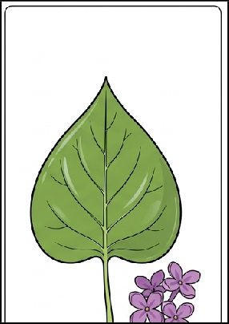

ADVANCED DICHOTOMICAL KEY:

- a) Leaves are in the shape of needles or scales GO ON 2
  - The leaves are broad (the leaflet is expanded) GO ON 4

- a) Needles grow singly and spirally on long shoots COMMON FIR TREE
  - The needles grow in tufts (bundles) on short shoots GO ON 3

- a) The needles are soft, light green; the cones are small (2-4 cm) and upright EUROPEAN LARCH
  - The needles are hard, evergreen; the cones are large (7-12 cm) ATLAS CHEDDAR

- a) The sheet is composed (several smaller sheets) GO ON 5
  - The leaf is simple (one blade) GO ON 6

- a) The leaves are arranged palmately (like fingers) HORSE CHESTNUT
  - The leaves are arranged pinnately (along the petiole) ACACIA

- a) The leaf edge is serrated or deeply incised MOUNTAIN MAPLE
  - The leaf edge is smooth and entire (heart- shaped) COMMON LILAC

Solution (path and name): ____________________________________________________

