ENO ART Lights for Friendship

OŠ Josip Pupačić Omiš
Republika Hrvatska
Marina Fistanić
has taken part in the ENO ART Lights for Friendship event and lit a lantern for common spirit and togetherness to oppose prejudices together with many other schools and students around the world.
Your commitment to cherish the friendships, environment and peace is highly appreciated.

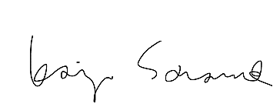
21 December 2023
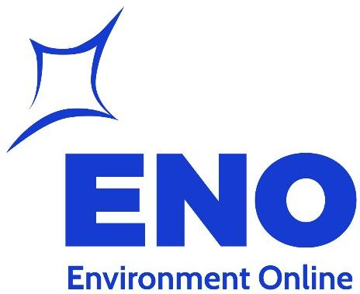
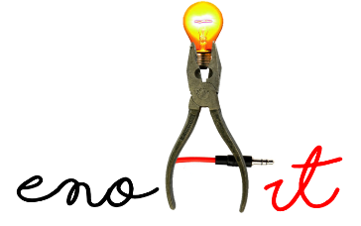
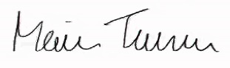
Maire Turunen Environmental education specialist
LIGHTS FOR FRIENDSHIP
Kaija Saramäki
Chairman of the board

